Author: | Nicole Rorher, Kori Miller
Title: | Change Cutsheet PDFs: Export Filename, Report Format, Header Information, Correct Calculations, & Add “Per Series”
Requested By: | Millroom/Side Dept. Production
Assigned Project #/Service Request:
Contents

I. Revision History 1

II. Justification 1

III. Functionality 2

IV. Testing Plan 2

V. Menu Considerations 2

VI. Security Considerations 2

VII. Technical Design Information 2

VIII. Effort Estimate 2

IX. Changes Requested after Approval 2

Revision History

Date | By | Purpose

Justification
CURRENT PROCESS:
Describe what is currently being done at Jayco, including data, screenshots in AX (including the locations/screens where information is located) and a layout of the process.
- Cutlist Summary report & Cutlist Cover Sheets do not correctly calculate totals if the same module is used in a sales order more than once. Additionally, Cutlist reports/millroom program does not currently account for “per series”
PDF Export naming
- PDFs are automatically exported to a folder with generic naming. Materials manually renames each folder to represent what it contains.
PDF Header Information
- PDFs header information contains information such as site, model, prefix, etc. used by side department personnel.

PROPOSED CHANGE:
Describe what changes in the process or application are being requested. Provide justification/reasoning/ROI on why this change will benefit Jayco and provide what those benefits are (time savings, mistake proofing, and enhanced workflow). Please include data/numbers to support the proposal.

- Change calculations to total each occurrence of the module instead of the total number of sales orders the module is in.
- Add “per series” field to correctly calculate multiples and allow for better optimization.

PDF Export naming
- Change the file naming during export process to include the following. This eliminates typing errors and time spent renaming manually.
- Fields in file name to be sorted A to Z and lowest to highest number.
  - Build schedule number(s)
  - Model(s)
  - Prefix(es)
  - Cut group(s)
  - Resource, if applicable

PDF Header Information
- Change the header information on these reports:
  - McaCutlistBaseReport.WorkOrderCoverSheet
  - McaCutlistBaseReport.WorkOrderSummary
  - McaCutlistBaseReport.WorkOrderDetail – L
  - McaCutlistBaseReport.WorkOrderDetail - S

- Modify current layout, update field names and add fields for:
  - Build schedule number
  - Total Units

- Review current formatting to eliminate unnecessary blank pages.

- Adding this information allows side department personnel to audit for errors before providing sheets to production. This will reduce the number of reworks and scrapped material.

Functionality
Put the specifics of the requested change in this section – include screenshot mock-ups, data requirements, workflow changes, calculations and anything else needed to perform this change.

McaCutlistBaseReport.WorkOrderSummary
McaCutlistBaseReport.WorkOrderCoverSheet

Reports are showing 24 of each module (14127198 & 14127197) for the following Prefixes:
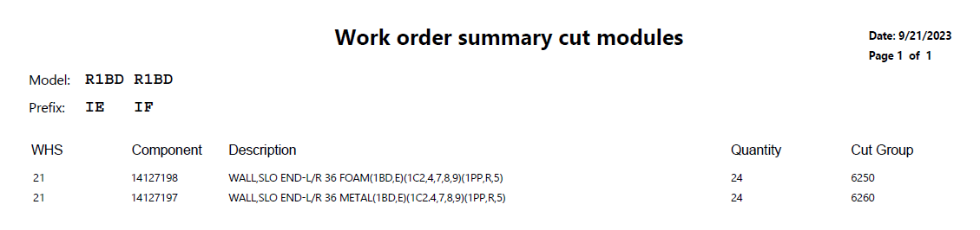
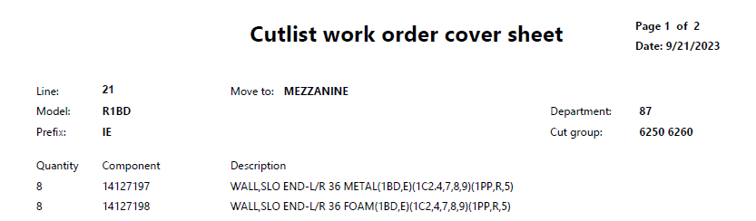
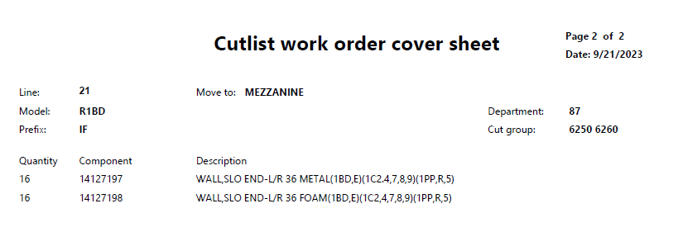

However, because each module is used twice in each sales order, the correct total should be 48.
In View Cutlist Records, the modules are listed a total of 48 times (twice for each sales order).
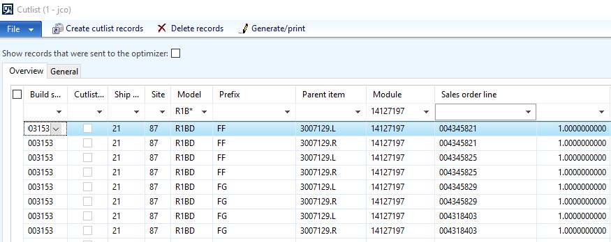

JCO > Production Control > Inquiries > Cutlist > View Cutlist Records
JCO > Production Control > Reports > Cutlist > Generate Cutlist Files and Cutlist Reports
McaCutlistBaseReport.WorkOrderDetail – L
McaCutlistBaseReport.WorkOrderDetail – S
McaCutlistBaseReport.WorkOrderSummary
McaCutlistBaseReport.WorkOrderCoverSheet

Add Per Series to cutlist records and calculate quantities correctly (based on multiples).
Per series can be found in BOM Lines:
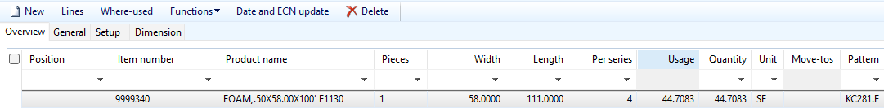

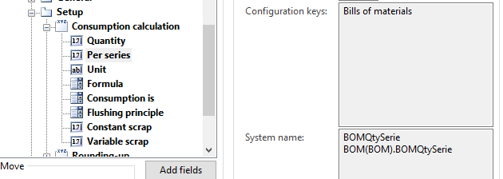

Add Per Series to Cutlist table (View Cutlist Records):
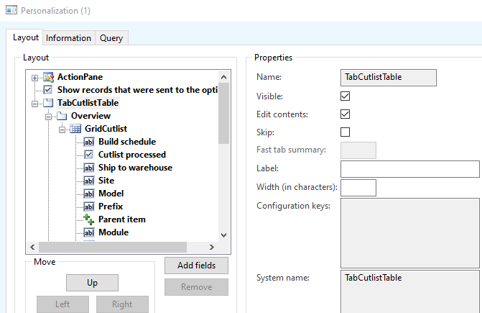

Add Per Series to Cutlist Reports and apply correct calculations to quantities.
Before:
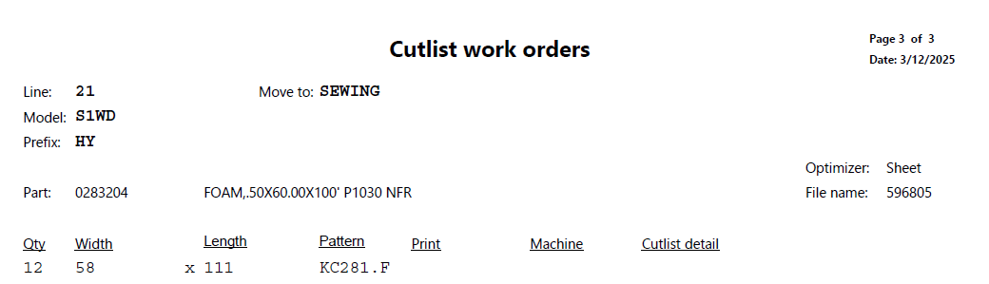

After:
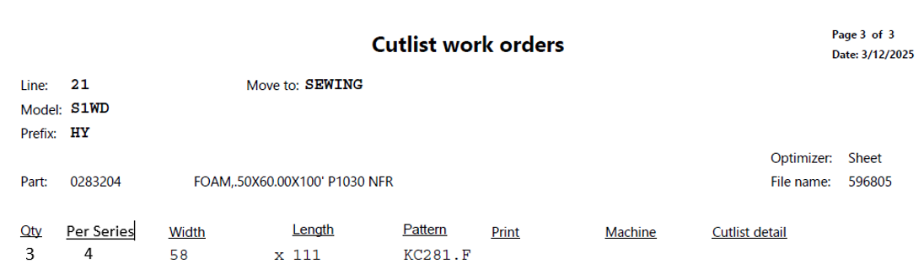

On the Cutlist Detail Reports, change the calculation of the Quantity field to account for “Per Series”
- If Per Series multiple = 2, divide the quantity by 2
- If Per series multiple = 3, divide the quantity by 3

PDF Header Information
- Add the Build schedule number and total number of units.
- Change field names as shown below, make alignment uniform, and allow wrapping.
- Review current formatting to eliminate unnecessary blank pages.

McaCutlistBaseReport.WorkOrderCoverSheet:
Current:
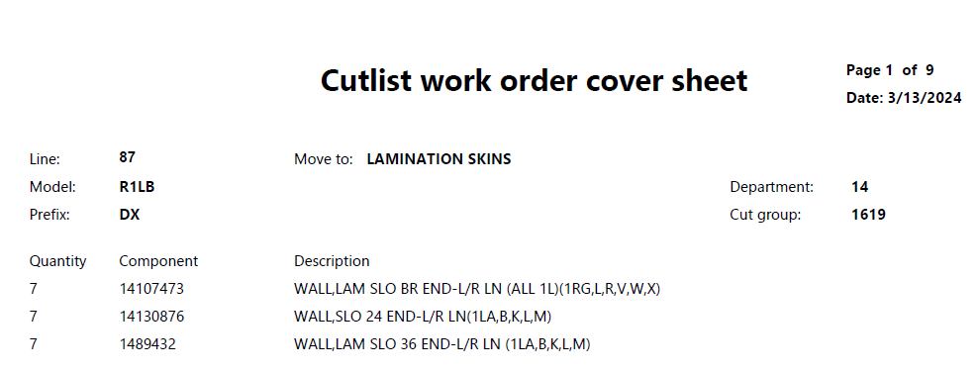

Proposed:
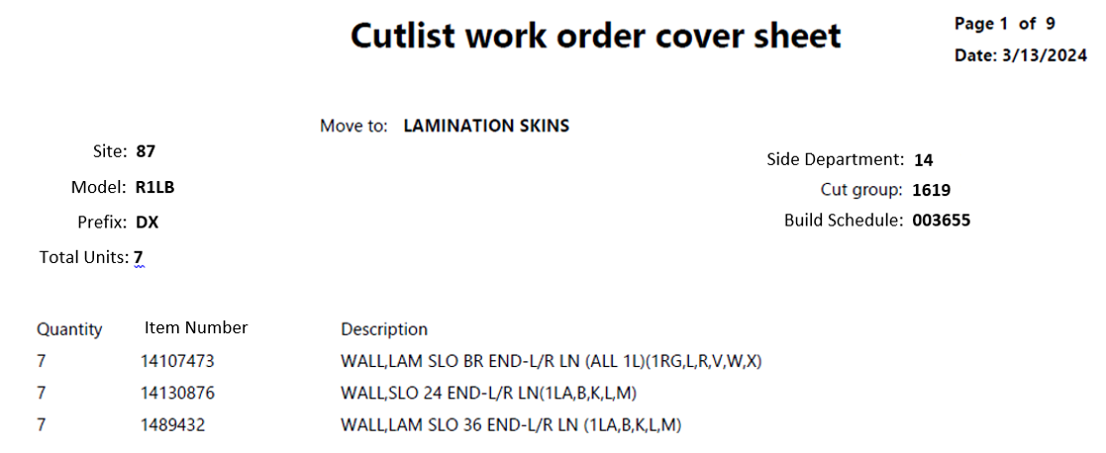

McaCutlistBaseReport.WorkOrderSummary:
Current:
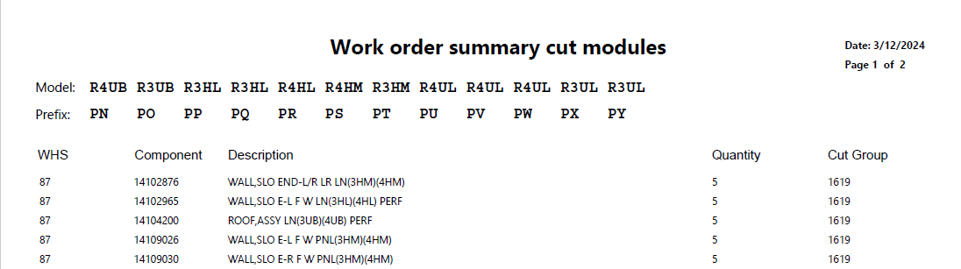

Proposed:
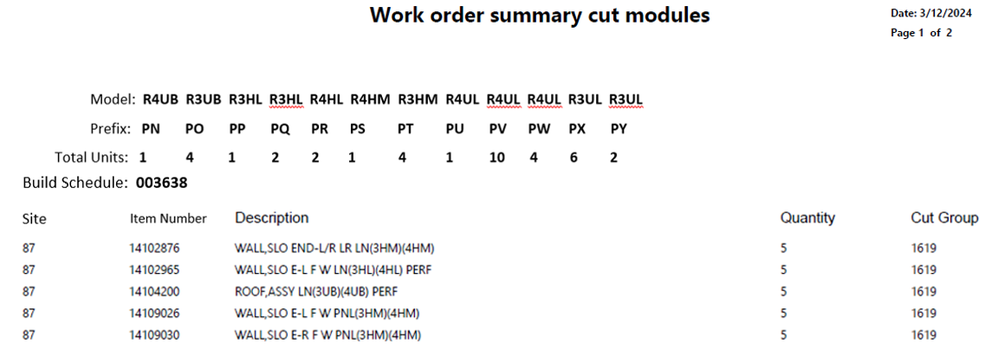

McaCutlistBaseReport.WorkOrderDetail – L:
Current:
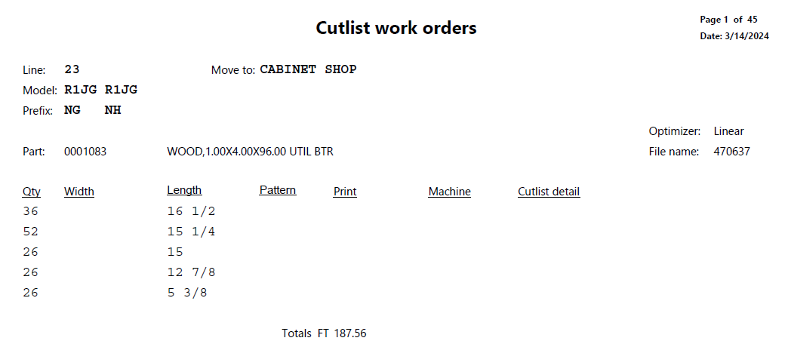

Proposed:
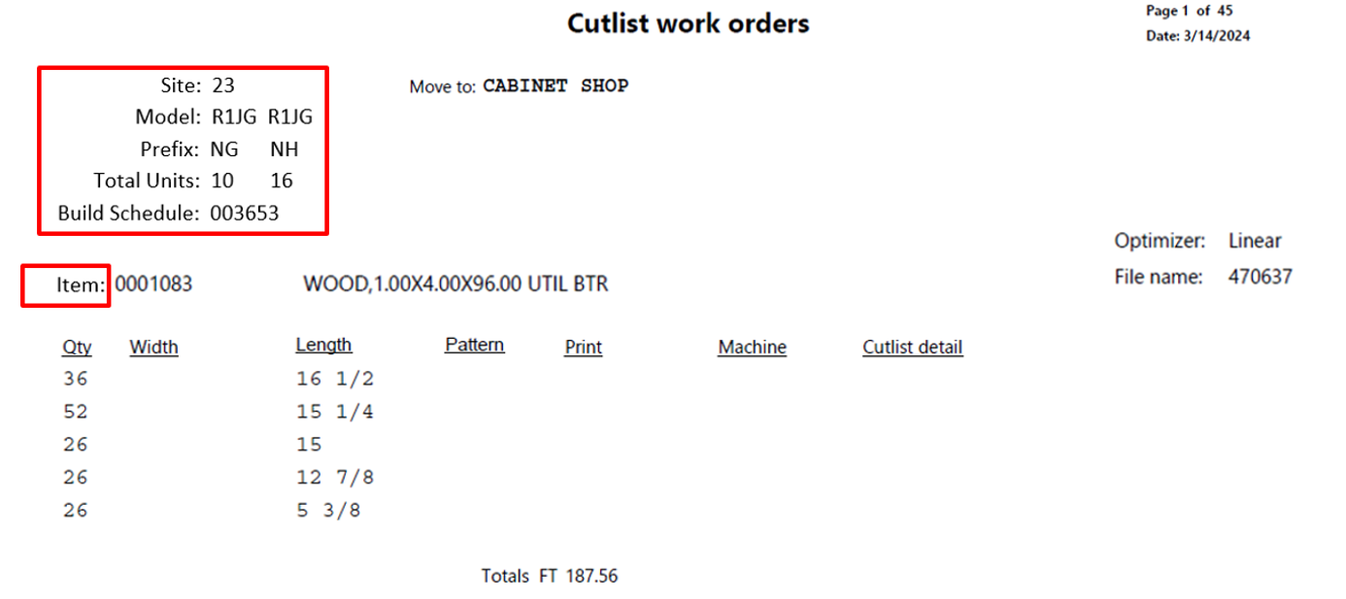

McaCutlistBaseReport.WorkOrderDetail – S
Current:
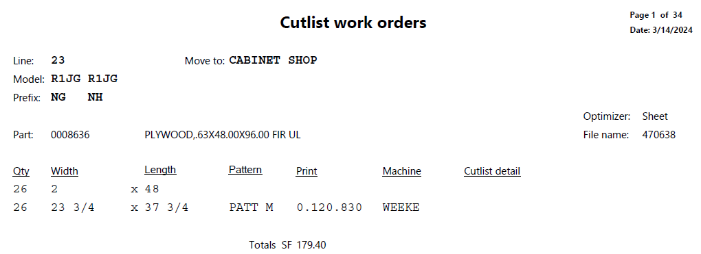

Proposed:
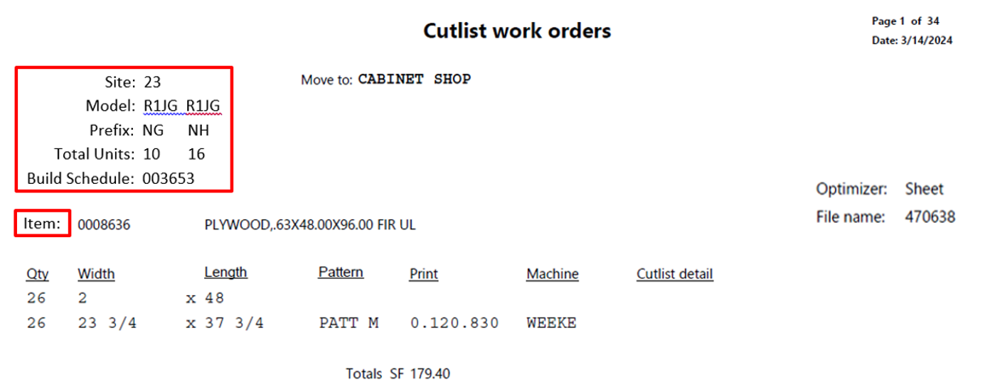

PDF Format Changes
Wrapping of fields:
- PDF files to extend/wrap field to include all information on all 4 PDF files where necessary.
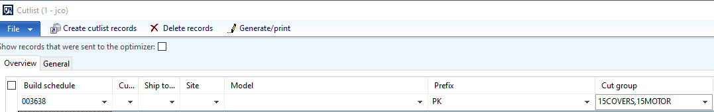

Current:
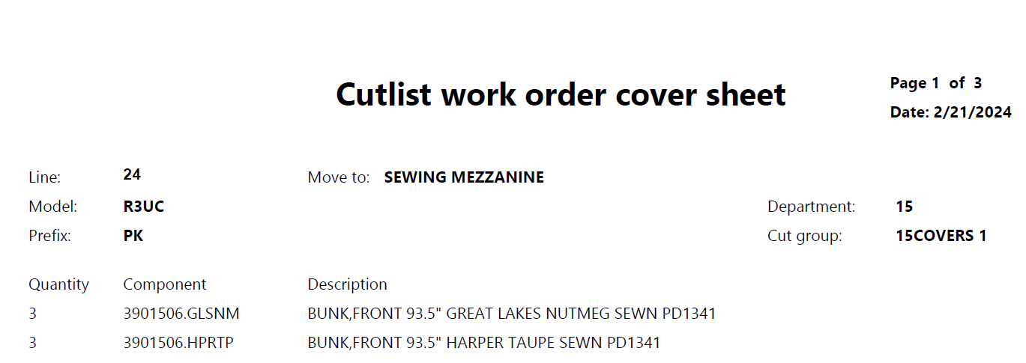

Proposed:
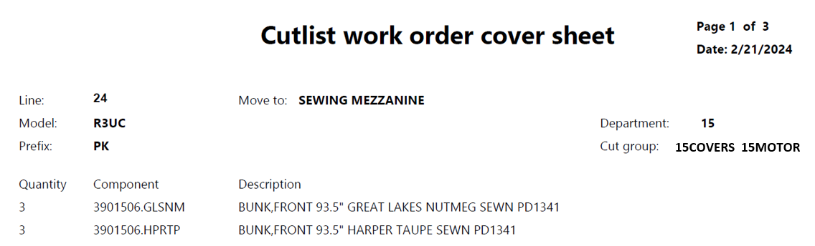

Blank Pages:
- This is an example of a blank page. All of the information is shown on page 19 and a blank page 20 was created.
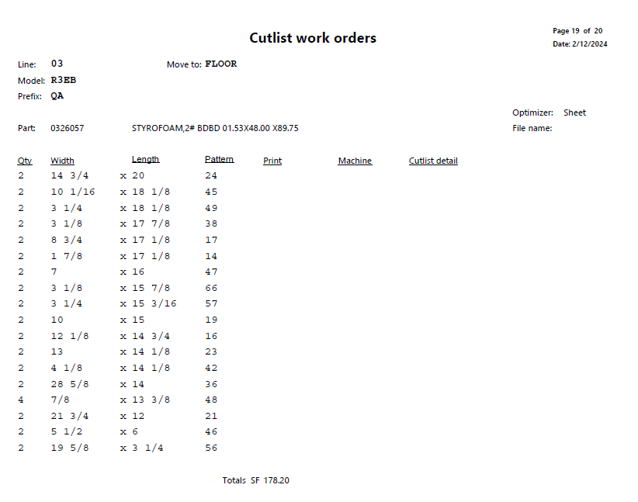

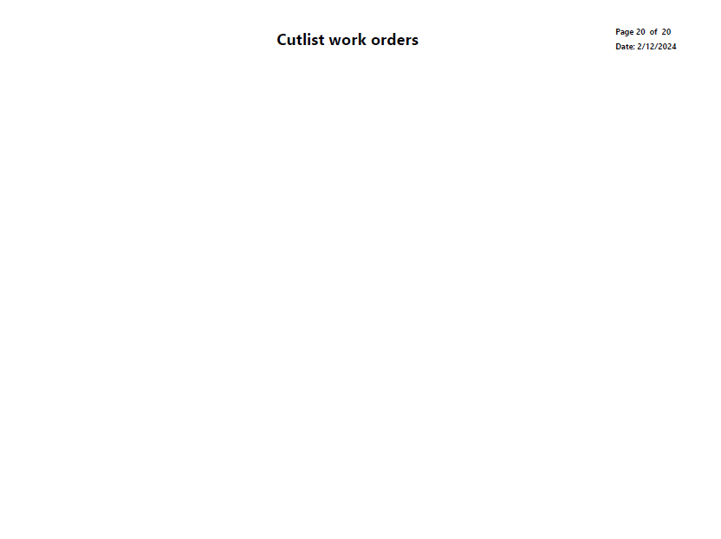

Testing Plan
- Describe the testing requirements in this section
- Provide both positive/negative testing instances to insure the change will not affect other areas.
- Include other groups that can be affected and should test (finance, AMS, materials, operations, etc.)

- Generate cutlist reports and validate total quantities.
- Run cutlist reports on a variety of parts and verify calculations (parts with and without per series)
- Generate cut files and confirm the file folder is named correctly.
- Review PDF files to confirm the total unit count and build schedule is correct. Confirm there are no blank pages.

SSRS/Report Considerations
List any SSRS/Reports that may be impacted in this section. Include any changes that may need made to reports.
- N/A

Menu Considerations
If there are any menu changes/considerations to deal with put them here.
- N/A

Security Considerations
List security considerations (who/what/when) for this change. Include groups/roles that should be able to use or not use this requested functionality.
- N/A

IT/Developer Sections Only

Technical Design Information
This is meant to define the “direction” that the developer should take during development. Use this section to provide additional information to a developer or outsourced party.

Effort Estimate (If required)

FUNCTIONAL
Task | Hours | Quoted By
NOTE: The hours above represent an ESTIMATE of time required to complete the change.

Changes Requested after Approval
<Optional section created as needed - A detailed description of changes requested should be listed here>
Requestor | Date | Change Description
Name | MM/DD/YY | Original submittal

